**Project Initialization and Planning Phase**

| Date | 12 July 2024 |
| --- | --- |
| Team ID | SWTID1720157891 |
| Project Name | Rice Classification using CNN |
| Maximum Marks | 3 Marks |

**Define Problem Statements (Customer Problem Statement Template):**

In the agricultural sector, the accurate classification of rice grain types is crucial for ensuring quality control and optimizing sorting processes. Traditional methods often rely on manual inspection, which is labor-intensive, time-consuming, and prone to human error. To address these challenges, this project aims to develop an automated system for rice grain classification using deep learning techniques.

Create a problem statement to understand your customer's point of view. The Customer Problem Statement template helps you focus on what matters to create experiences people will love. A well-articulated customer problem statement allows you and your team to find the ideal solution for your customers' challenges. Throughout the process, you’ll also be able to empathize with your customers, which helps you better understand how they perceive your product or service.

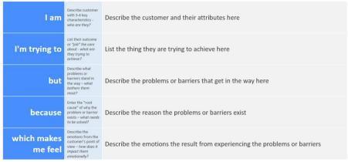

Reference: https://miro.com/templates/customer-problem-statement/

**Example:**



|  |  |  |  |  |  |
| --- | --- | --- | --- | --- | --- |
| **Problem**  **Statement (PS)** | **I am**  **(Customer)** | **I’m trying to** | **But** | **Because** | **Which makes me feel** |
| PS-1 | Farmer | Get a good yield in my Rice Crop | Not able to do so | No proper quality of seeds | There is a huge need for good approach of selecting seeds |
| PS-2 | Quality Inspector | Check the quality of Rice Grains | Not able to do so | No proper technology for segmentation seeds | There is a huge need for good approach of selecting quality seeds |